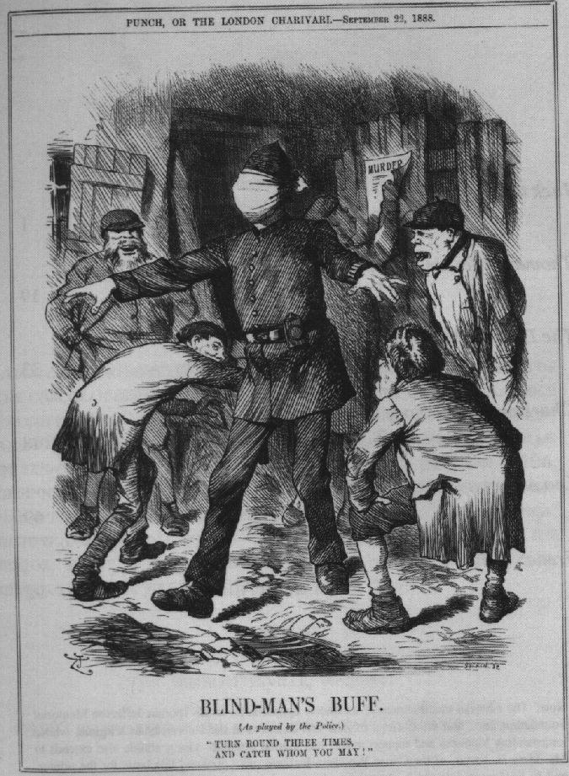

**Representation 3: “ Blind Man’s Buff” a cartoon from Punch magazine Sept. 1888**